WELCOME TO

SKIPPER CLEMENT SKOLENS FRITIDSORDNING
- a good place to be

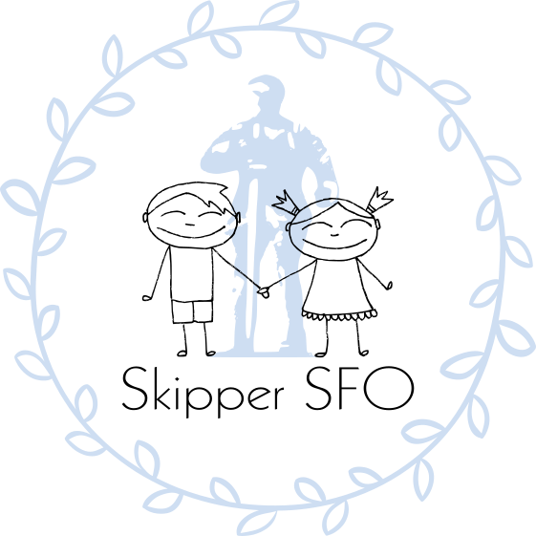

2025-26

We would like to welcome you to Skipper SFO
In this welcome booklet you can find information about values, practical information, payment, opening hours etc.
A warm welcome from the staff of Skipper SFO
Contents

Values and visions in Skipper SFO 3
Practical information 4
Opening Hours 4
Payment 4
Switching payment module……………………………… 4
Sibling rebate 4
Holiday opening in Skipper SFO 5
Closed days 5
Morning SFO 5
What can you expect from Skipper SFO 6
What do we expect from you 6
Boden (Stall) – Fruit arrangement 7
Location rooms in SFO 7
General rules in Skipper SFO 8
Parties for the whole family 9
Bullying 9
Policy concerning sending children 9
Contact to Skipper SFO 10
Telephone numbers to Skipper SFO 10

Values and visions in Skipper SFO

- Security creates well-being and development for the child. If the child does not feel safe, he/she cannot evolve.

- Empathy is putting yourself in someone else’s place. We support the child’s interaction with the other children and help them to verbalize feelings and actions.

- Diversity, we recognize that everyone is different. We do not have to like everyone, but we must respect each other’s differences.

- Presence, we are present and take time to listen and show interest and care for each other.

It must be safe, fun, stimulating and educational to go to Skipper SFO

Our vision is that Skipper SFO is a place where children have freedom to choose between a variety of activities or just relax and play. Activities include various workshops, activities in the hall, bonfires, trips out of the house etc. In Skipper SFO, we are especially good at launching long-term theme programmes such as Halloween, Olympics, circus and much more.

We also try to create the best framework for your child's well-being, development, learning and education. We see the whole child and support their imagination and creativity. We support and develop the child's relationships and the communities they are a part of.

Practical information

Skipper SFO is open for students from 0. klasse to 3. klasse and students from the International Department – S1 to S4.

Opening Hours
From 06.45 to 08.10
From 11.30 to 16.30

Payment
See current prices on the school's website.
Payment is charged monthly for 11 months.

These prices do not apply to holidays, where payment is made separately.

Withdrawal
If you wish to withdraw your child from Skipper SFO, this can be done via the website. Payment is required for the current month + 1 month.

Sibling Discount
A discount is given to children who have siblings. See the school's website.

Holiday Opening at Skipper SFO
We are open during school holidays, which are the following periods:

- Winter holiday, week 8.
- Monday, Tuesday, and Wednesday before Easter.
- First and last week of the school's summer holiday.
- Autumn holiday, week 42.

If your children are in Skipper SFO during the holidays, it costs 150 DKK per day.
You will be notified via Parentsintra when individual holiday periods are approaching. Here you must also register your child and pay via the payment link so we have an overview of the number of children. Since we often want to leave the house during the holidays, it is important that you make sure to call, if your registered times change.

Closed days
- Summer holidays 4 weeks (week 28, 29, 30 & 31)
- Day after Kristi Himmelfartsdag (Ascension Day)
- Between Christmas and New Year
- Constitution Day

Morning SFO
Morning-SFO is open from 6.45 to 8.10. Children who arrive before 7.50, MUST be in the morning SFO, which is located on the 1st floor at Skipperhuset. When the child is in the morning SFO, the child's first task is to say good morning to the Pedagogue. Then some children go out and play, others read a book, play a game or relax and wake up/enjoy themselves before the school day begins.

What can you expect from Skipper SFO?
You can expect that we are always aware of your child's well-being and development, and that we will always approach you if we have information about your child. We start with an open and honest dialogue, as well as a positive parenting collaboration. You can expect that we send a newsletter about well-being and important information, once a month.

We expect your child to come to school with appropriate outerwear, and you can expect us to remind your child to wear appropriate outerwear when we are out. In addition, you can also expect us to call you if there is a lack of extra clothes when the need arises. Forgotten clothes, etc. are put down in the basement.

What do we expect from you?
We expect you to inform us about significant changes in your child's life that affects his/her well-being. We expect you to check yourself out and say goodbye to one of the pedagogues before going home. Each contact pedagogue holds a SFO assembly once a week, and we expect your child to participate. We also expect you to update your information on Parentintra and Famly and keep updated on the information that is being posted.
We expect you to complete mobile calls before you pick up your child.
We also expect you to write names in clothing - footwear - purse - mittens etc. and for rainwear - outdoor clothing - a change of clothes. We also expect you to empty your children's wardrobe for a holiday, so the room can be cleaned, and put the box for changing clothes into the class on a table.

Boden (Stall) – Fruit arrangement
Boden is a healthy place that allows for a small meal in the middle of the day. Boden is the children's little grocery store, where fruit and vegetables are sold as well as snacks of different varieties.
Boden opens every day about 14.00. Here it is possible to buy fresh fruit for DKK 1 each.
Each child can along with a friend be in Boden to help and learn how to prepare the various fruits and vegetables and then sell them. They accept money and keep accounts. Each child must buy a maximum of DKK 3 per day. (Food from the stall is not a substitute for the child's packed lunch.)

Location rooms in SFO
The purpose of the function room in Skipper SFO is that the children choose activities according to their desire and interest and not what is in their respective classroom. This will promote children's relationships across groups and departments as well as add to the diversity in SFO. The children can here get relationships with each other around an interest that they share together.

General rules in Skipper SFO
- After the last school lesson, the children go to SFO. They start by checking into SFO via Famly-App. It is the child and the home's responsibility for checking out and saying goodbye to an adult in the group (IMPORTANT - due to Security).

- Tablets, mobile phones etc. must remain in the bag throughout the SFO time.

- Outerwear and bag must be in the wardrobe.

- Everyone cleans up after themselves for the sake of each other and our things. This the child must remember before he / she goes home, here you are expected to help your child remember this so that the other children do not clean up alone.

- The children may only play on mobile phones, tablets and other small computers on the first Friday of each month - however for a limited time - according to the staff's assessment.

- Rules for mobile phones: It is forbidden to take pictures and video recordings with mobile phones. The children must only call or write text messages by appointment with an adult. You can always get in touch with us by phone if there is anything we need to inform your child about. So, all contact is made via the mobile phone which belongs to the group the child is attached to.

- We encourage play dates to be agreed upon the day before so that both set of parents are informed. If the children want to go home with each other, then we let the parent who collect their child first, assess whether it can be done, and then the parents can contact each other.

Parties for the whole family
Twice a year we have a party in Skipper SFO - A summer and Christmas party. The dates for the two events will be announced well in advance via the ParentIntra. The summer party is in May / June, and the Christmas party is in November / December.

Bullying
Bullying is not accepted and tackled immediately, in close cooperation with parents and the school.

Policy concerning sending children
We can help to remind your children to go to their appointments (such as ‘musikskole’) during SFO-time - to a degree. We see it as part of the cooperation around your children, but in this context, we also expect that there is a shared responsibility for the children to become as self-reliant as possible. We are aware that children in 0.kl. must have more help than children in 3.kl.
We do not send children out to the road in connection with a pickup. You need to come in and let us know that you are picking up your child/children and give us the opportunity to tell you about the day's events.

Contact to Skipper SFO

Mail to staff and SFO leader: via ParentIntra

Telephone numbers to Skipper SFO
Mobiles to the individual groups open every day from 11.45
Morning SFO + holiday use 41320066 mobile number.

Skipperhuset (0.- 2.Kl.) 41 32 00 66
Clementhuset (S1-S4 & 3.kl. & Club) 41 32 00 69
SFO Leader (Camilla) 41 32 00 70

Find the latest updates on the website
www.skipper-clement-skolen.dk
Enter through the tab: SFO

Remember - we send out news through ParentIntra

