**Skipper**

**Clement**

**School Year 2025/26**



**Index**

1. First day after the summer holidays

2. School timetables 2025/26

3. Holiday plan 2025/26

4. Payments 2025/26

5. School fees 2025/26

6. SFO (After School Services) 2025/26

7. Financial help with school fees and SFO 2025/26

8. School dentist during the summer holidays

9. School Library

10. Bus card

11. Confirmation

12. School office

1. First day after the summer holidays

**Monday 11th August**

|  |  |
| --- | --- |
| ***8.10*** | ***1. – 6. klasse and Stage 2 - 7***  Students meet in the school hall.  Welcome by the School Principal  The classes are with the class teacher until 11.40. |
| ***9.00*** | ***7. – 9. klasse and Stage 8 - 10*** |
|  | Students meet in the school hall.  Welcome by the School Principal  The classes are with the class teacher until 12.30.  **Euro Classes and Stage11: Separate program for the day is sent out to students.** |
| ***10.00*** | ***O. klasse and Stage 1***  Students meet in the school hall.  Welcome by the School Principal  The classes are with the class teacher until 13.00, hereafter SFO is open.  Parents are welcome this day from 10 - 10.30 and from kl. 12.30. |
|  |  |
|  | |

2. School Timetable

Access from the front page of the school. There is a yellow bar at the top of the front page with the timetable.

Website: [www.skipper-clement-skolen.dk](http://www.skipper-clement-skolen.dk)

**Please note that school is closed on 21st November.**

3. School Calendar

The school holiday timetable can be seen on the school’s website under ”Practical Information” from 5th July.

 Website: [www.skipper-clement-skolen.dk](http://www.skipper-clement-skolen.dk).

4. Payments 2025/26

The school asks for monthly payments. This means that school fees payments, SFO, school camp and book replacement will be charged monthly from August to June (July free of charge). The deposit (minus registration fee) will be credited to the first two invoices. According to the agreement, the School can offer half-year or full-year payment.

All debtors **MUST** register with ‘Betalingsservice’. You must register at your bank, unfortunately, we cannot do it for you. The school fee payments will be deducted automatically from the account of anyone who has registered with ‘Betalingsservice’.

In special cases, payment via F1 card can be arranged. All payments outside of PBS incur a fee of 100 kr.

Upon deregistration, school fees are calculated for the current month plus one month from the date we receive the deregistration. Deregistration must be done on the school's website.

Registration for and withdrawal from SFO / club is on the school's website and is valid from the date the form is completed. The withdrawal deadline is the current month plus one month. Full months are paid. Holiday payment for SFO is still per day.

5. School Fees

**Danish Department:**

Børnehaveklasse - 3. klasse 1,940 kr. per month

4.klasse – 9. klasse 2,095 kr. per month

Sibling reduction:

2nd child 300 kr. per month

3rd child 600 kr. per month

4th child 1,940 / 2,095 kr. per month

Camp

In 6th class additional per instalment for school camp 280 kr. per month

In 8th class additional per instalment for school camp 400 kr. per month

**Euro Classes/10. Kl. (Danish Dept.)**

School Fee: 2,095 kr. per month

School trips: 13,000 kr.

**International Department; for students with CPR number.**

Stage 1 to Stage 4 2,395 kr. per month

Stage 5 to Stage 11 2,550 kr. per month

Sibling reduction:

2nd child 1,095 kr. per month

3rd child 1,095 kr. per month

4th child 2,395 / 2,550 kr. per month

School trips

In Stage 6 additional per instalment for school camp 255 kr.per month

In Stage 8 additional per instalment for school camp 460 kr. per month

In Stage 10: additional per instalment for school camp 460 kr. per month

In Stage 11: additional per instalment for school camp 185 kr. per month

**New students for admission, there is a 1,000 kr. enrolment fee.**

**The notice period for changing schools is current month plus one month. Payment deadline is the 5th of the month (July free of charge)**

6. SFO (After school services & Club)

**Fees are payable with 11 months per school year.**

For students in 0 – 3rd Grade and Stages 1 – 4 the school offers SFO after school hours.

 SFO 1,170 kr. per month

* Sibling reduction 220 kr. per month

KLUBBEN (4.-5. klasser and Stages 5 & 6): 770 kr. per month

There is only 1 module in SFO. This means that SFO can be used freely no matter how many hours are needed for the individual weeks. It will be more flexible for all families not to have to count hours, for example, when there are trips or other activities that the children would like to participate in.

**Registration in SFO and club is done via the form on the school's website under the tab SFO.**

**Withdrawal from SFO and club takes place via the form on the school's website under the tab SFO** and is valid from the date the form is filled in. The withdrawal deadline is the current month plus one month. Full months are paid. Holiday SFO payment is still per day. **Payment deadline is the 5th of the month (July free of charge)**

SFO is open from 6.45 - 8.00 and from 11.30 - 16.30.

SFO starts in week 32. Holiday registration is done via ‘Nemtilmeld’. Price per day is 150 kr.

7. Application for financial help with School Fees, and SFO

The application for help with school fees and SFO can be found on the school’s website under ”Admissions” or in the school’s office. You can apply once a year.

Latest date for application: 29th August 2025. **Please remember to submit an application for each school year.**

Eventual grants will be deducted in February – June 2026.

8. School Dentist

Skipper Clement School uses the dentist clinic at:

Gl. Hasseris skole

Mester Eriks vej 85, 9000 Aalborg

Telephone inquiry 8.00 – 15.00, tel. 99 31 76 90

The above telephone number refers outside the opening hours to the emergency dentist.

9. School Library

All text books must be covered with paper within the 1st week.

DO NOT use self-adhesive covering film, cellotape or glue.

Look through all the books before covering. If they are damaged or if the CD is missing, contact us immediately. DO NOT try to repair the books yourself.

**Lost or damaged books must be replaced.**

10. Bus Card

Nordjyllands Trafikselskab does not cover Skipper Clement School for issuing school bus cards. It is therefore not possible to order bus cards from us. The school's students must therefore instead use a travel card (Rejsekort) or a commuter card (Pendlerkort).

11. Confirmation

Skipper Clement Skolen collaborates with 2 churches for confirmation:

* Ansgars Kirken (2nd Saturday in May)
* Vor Frelsers Kirke (2nd Saturday in May)

The classes are distributed as follows:

* + 7.a and 7.c are offered confirmation preparation and confirmation in Vor Frelser Kirke
  + 7.b is offered confirmation preparation and confirmation in Ansgars Kirken
  + Stage 8 is offered confirmation preparation and confirmation in Vor Frelsers Kirke

Students will be confirmed the second Saturday in May.

The school's official Blue Monday is always the day after the 2nd Sunday in May.

**For other inquiries please contact the church.**

12. Addresses, telephone, office hours etc.

The School Office is open on all school days from 8.00 – 15.00  tel. 98 12 11 88

Heather Knudsen

Skolesekretær International Afdeling

+45 41 32 00 75

Lis Møller Lyngse

Vikar- og praktikkoordinator

+45 26 37 77 73

Morten Nielsen

IT Supporter

+45 41 32 00 58

 Birgitte Pedersen

Kontorleder

+45 41 32 00 64

Maria Buus Jensen

Skolesekretær

+45 41 32 00 63

Gitte Hyldig

Skolesekretær

+45 41 32 00 65

|  |  |
| --- | --- |
| School Leader  Peter Würtz, tel. 41 32 00 50  Souschef– Danish Department  Anne Krogh Rye, tel. 41 32 00 51  Souschef - International Department  Jenny Rohd-Thomsen, tel. 41 32 00 53  Department Leader  Kennet Andersen, tel. 41 32 00 59   Leader of SFO  Camilla Kirchoff, tel. 41 32 00 70  Janitor  Niels Christian Hejlesen, tel. 41 32 00 54 | Euro Classes Co-ordinator  Claus Gaihede, tel. 22 27 90 43    School Board per 1/8 2024  Chairman  Louise Esko Refshøj, tel. 28 69 39 82  Deputy Chairman  Marit Lund Agerbæk, tel. 22 91 92 10  Emma Balkin, tel. 50 49 28 44  Maria Andersen, tel. 22 44 79 08  Thomas Bjuring, tel. 22 47 44 49  Sharelle Vandborg  Claus Gajhede |

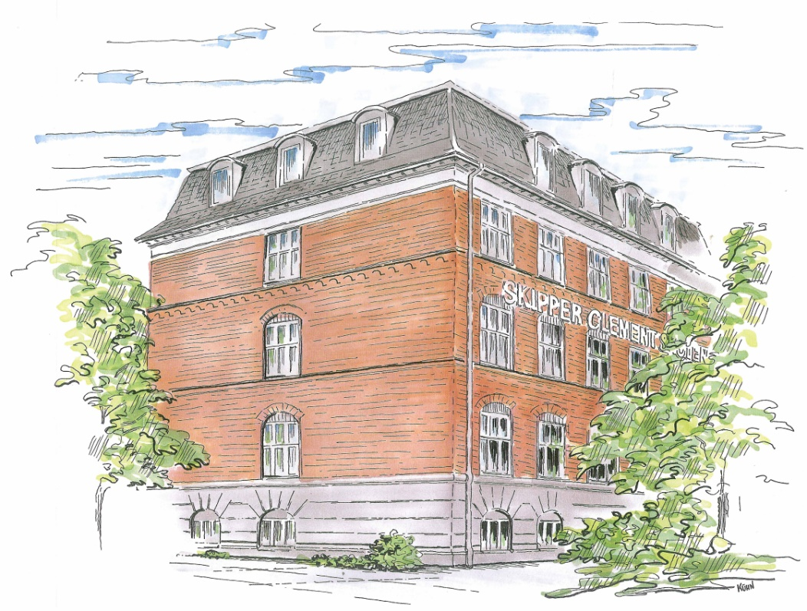



www.skipper-**c**lement-skolen.dk